
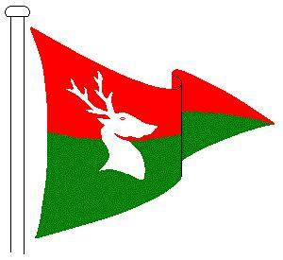
NOTICE OF RACE
2016 Hunts S.C. Supernova Open
Saturday 11th June 2016
----------------------- o0o -----------------------
Entries are invited from competitors for the 2016 Hunts S.C. Supernova Open
Organised by HUNTS SAILING CLUB
Harrison Way, St Ives, Cambridgeshire, PE27 4YA
----------------------- o0o -----------------------
- Rules: The regatta will be governed by The Racing Rules of Sailing 2013-2016, the Prescriptions of the Royal Yachting Association, Class Rules and Hunts Sailing Club’s Sailing Instructions. Competitors should note that Hunts S.C. implements the RYA Racing Charter and that they will be required to undertake to sail in compliance with the Charter, which can be found at the front of the RYA rule book and at the point of event entry.
- Eligibility & Entry: The regatta is open to all boats of the Supernova class. Eligible boats may enter by completing the entry form on the day. This will be available on the morning of the event from 09h00.
- Entry Fee: An entry fee of £10 is payable on the day.
- Schedule: Three races are scheduled for the event, with two results to count. A competitors’ briefing will be held in the club house at 10h30. The scheduled time of the warning signal for the first race is 10h55.
1st Race start: 11h00
2nd Race start: 13h00
3rd Race start: as soon as possible after 2nd Race (back-to-back)
- Sailing Instructions: The Sailing Instructions are available on the club website: www.huntssc.org.uk.
- Prizes: Prizes will be awarded for 1st - 3rd places. Other spot prizes may be awarded depending on the size of the entry.
- Disclaimer of Liability: Competitors participate in the regatta entirely at their own risk. Hunts Sailing Club will not accept any liability for material damage or personal injury or death sustained in conjunction with or prior to, during, or after the regatta.
- Insurance: Each participating boat shall be insured with valid third-party liability insurance with a minimum cover of at least £2,000,000 or the equivalent.
----------------------- o0o -----------------------
Further Information:
Competitors are invited to also attend the Class Association Training day with RYA coach Andrew Kerr at Hunts S.C. on Friday 10th June, free to class members. Food and drinks will be available throughout both days.
Camping will be possible Thursday 9th and Friday 10th, for further information about this or the event please contact Jon Pebody at jon@pebody.co.uk, by phone on 07801 717 312. Or go to the club website www.huntssc.org.uk.

