
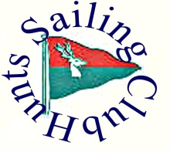

Supernova Class Association Open Meeting Entry Form

Please enter the following boat for the Association Open Meeting on 30th October 2021

Class …Supernova….………….... Sail number …..……….…………………...

Helm ……………….…………….. Club …………….…………………

Category …………Standard / Master (50+) / Veteran (60+) / Lady / Youth

I agree to be bound by the Racing Rules of the ISAF as modified by special prescription of the RYA, the RYA Racing Charter, class rules and Hunts Sailing Club Open Meeting Sailing Instructions.

I declare that I hold:

3rd party insurance to a minimum of £2,000,000,
a valid class certificate (if required by the class association)
that I am a member of the RYA or a RYA affiliated club
and will wear an adequate personal flotation device.*

I agree to sail in compliance with the RYA Racing Charter.

Signed ……………………………………………..
(Parent / Guardian to sign if competitor is under 16)

Name ……………………………………

Address ………………………………………………………………………………………….

…….…….……………………………………………………………………………..

…….…….……………………………………………………………………………..

Emergency contact telephone number …………….…………………………….

Entry fee : £ 10 for Open Meeting Paid ? ….….…………
…………………………………………………………………………………………………………………………………………………………
* ‘Adequate personal flotation device’ means a buoyancy aid of at least 50N to BS EN ISO 12402-5:2006 or equivalent

