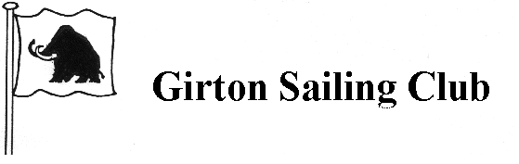

Open Meeting Entry Form

2021 Supernova Open

Please complete in block capitals.

Helm’s Full Name : ______________________________________________

Fleet: Master, Veteran : ___________________________________________

Address : ______________________________________________________

______________________________________________________________

Telephone No : _________________________________________________

£10 Entry Fee Paid : yes no

Circle as appropriate

Sail Number : __________________________________________________

Dinghy’s Name : ________________________________________________

The entry fee is £10 payable at registration.

I am a member of ______________________________________ Club, and I agree to be bound by the Racing Rules of Sailing, RYA prescriptions, Rules of the Class Association and the Sailing Instructions. I further declare that I have arranged Third Party Liability Insurance in respect of the boat entered for a minimum of £3,000,000 and that the term of the insurance will cover the full period of the Race Meeting.

Signed : ________________________________ Date : ________________

I am a member of the Supernova class association yes no

Circle as appropriate.

