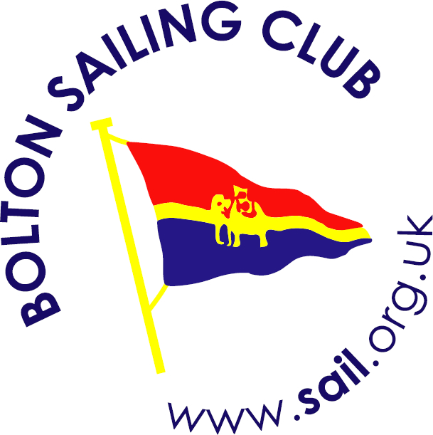
Event: Supernova Open Meeting
Venue: Bolton Sailing Club
Date: 25th APRIL 2015

Please note boats to cleaned before arrival at Bolton SC.
The Racing On Saturday 25th will commence at 11:30 hrs.
Time of Briefing: 11.00am Time of First Race: 11.30am
Total Races: 3 Races to Count: 2
Entry Fee: £10:00
Lunch: Hot food and refreshments will be available from the galley
Accommodation: Camping will be available on site, contact: Keith Roberts (home) 01772 432254, (mob) 07503728000
The bar will be open after sailing.
Prizes: The prizes will be better than ever this year, so put this open event in your diary now!
Contact: Email: keith@sail.org.uk or have a look at the Club Web Site: www.sail.org.uk + for accommodation http://near.sail.org.uk

